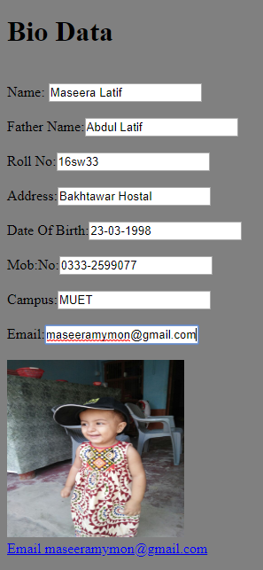

<!DOCTYPE html>

<html>

<head>

<h1>Bio Data</h1>

</head>

<body bgcolor="gray">

<br>

Name:

<input type="text" placeholder="Type your name" ><br><br>

Father Name:<input type="text" placeholder="Type your father name"><br><br>

Roll No:<input type="text" placeholder= "Roll number"><br><br>

Address:<input type="text" placeholder="Home address" ><br><br>

Date Of Birth:<input type="text" placeholder="Date Of Birth" ><br><br>

Mob:No:<input type="number" placeholder="Mob number"><br><br>

Campus:<input type="text" placeholder="Campus"><br><br>

Email:<input type="text" placeholder="Email address"><br><br>

<img src="D:\FAMILY\UMI\IMG-20160910-WA0049.jpg" height="200" width="200"><br>

<a href="maseeramymon@gmail.com">Email maseeramymon@gmail.com</a>

</body>

</html>